**Batch: C - 3 Roll No.: 16010122096**

**Experiment / assignment / tutorial No. 1**

|  |
| --- |
| **Title:** Study of Artificial Intelligent project. |

**______________________________________________________________________Objective:** To study various AI projects for their architectures. Complexity, programming language, applications and other AI related concepts.

**______________________________________________________________________**

**Expected Outcome of Experiment:**

|  |  |
| --- | --- |
| **Course Outcome** | **After successful completion of the course students should be able to** |
| **CO1** | Understand the history & various application of AI and choose appropriate agent architecture to solve the given problem. |

**______________________________________________________________________**

**Books/ Journals/ Websites referred:**

1. **http://en.wikipedia.org/wiki/List_of_artificial_intelligence_projects**
2. [**http://www.cs.cornell.edu/courses/cs478/2002sp/mllinks/interesting_ai_demos_and_project.htm**](http://www.cs.cornell.edu/courses/cs478/2002sp/mllinks/interesting_ai_demos_and_project.htm)
3. **http://homepages.inf.ed.ac.uk/rbf/AIMOVIES/AImovai.htm**
4. **“Artificial Intelligence: a Modern Approach” by Russell and Norving, Pearson education Publications**
5. **“Artificial Intelligence” By Rich and knight, Tata McGraw Hill Publications**

**______________________________________________________________________**

**Pre Lab/ Prior Concepts:**

History and evolution of AI, Artificial intelligence: definitions and theories.

**______________________________________________________________________**

**Historical Profile:**

AI research is highly technical and specialised and is also divided by several multidisciplinary technical issues. So far there are many projects those have been developed and are in progress to work on those issues. Students must learn the applications of intelligent robots by studying various such projects to know the depth and complexity of the course.

**_____________________________________________________________________**

**New Concepts to be learned:**

Applications of AI, Current research and future research potential in the field.

**_____________________________________________________________________**

**Chosen Classical Project Name 1:** DART

**Project Description:**DART was a sophisticated expert system designed to manage and optimize logistics for the U.S. military. It was primarily developed during the 1990s to address the complexities of military supply chain management. The tool provided real-time solutions for deploying personnel, equipment, and supplies effectively during military operations. By leveraging advanced algorithms and decision-support systems, DART allowed planners to explore multiple scenarios, replan based on changing conditions, and ensure optimal resource utilization.

**Project category/field:** Expert System

**Agent architecture:** Rule-based architecture

**Programming language in which the project is/was developed:** Lisp

**Awards won by the project/strengths, weaknesses, highlights of the project:**

* **Strengths:**
  + Revolutionized military logistics by enabling efficient, data-driven decision-making.
  + Allowed rapid reallocation of resources in response to dynamic battlefield conditions.
* **Weaknesses:**
  + Highly domain-specific and not easily transferable to non-military contexts.
  + Relied heavily on data accuracy; errors in inputs could compromise results.
* **Highlights:**
  + Successfully deployed during Operation Desert Shield and Operation Desert Storm, significantly improving operational efficiency.

**Nature of the project: Real-world application**

* DART was deployed in live military operations and demonstrated its value by saving time and resources during critical missions.

**Applications of the project:**

* Military logistics planning
* Large-scale resource allocation and optimization
* Supply chain management in high-pressure scenarios

### 

**Chosen Classical Project Name 1:** Deep Blue

**Project Description:**Deep Blue was an advanced chess-playing computer developed by IBM that made history by defeating world champion Garry Kasparov in a six-game match in 1997. It combined brute-force computation with sophisticated evaluation functions and chess-specific knowledge. Deep Blue evaluated millions of positions per second and employed advanced search techniques to select optimal moves. Its victory was a milestone in AI, showcasing the potential of machines to tackle complex decision-making tasks.

**Project category/field:** Game AI

**Agent architecture:** Minimax with alpha-beta pruning and parallel search architecture

**Programming language in which the project is/was developed:** C

**Awards won by the project/strengths, weaknesses, highlights of the project:**

* **Strengths:**
  + Demonstrated AI’s ability to master strategic games requiring deep planning.
  + Pioneered techniques that influenced other AI applications.
* **Weaknesses:**
  + Domain-specific; could not generalize beyond chess.
  + Relied heavily on hardware advancements rather than purely algorithmic innovations.
* **Highlights:**
  + First AI system to defeat a reigning world chess champion in a standard chess format.

**Nature of the project: Real-world application**

* Deep Blue was a practical demonstration of AI capabilities and sparked discussions about machine intelligence.

**Applications of the project:**

* Chess AI development
* Research in decision-making algorithms
* High-performance computing and parallel processing

### 

**Chosen Classical Project Name 1:** Stanford Cart

**Project Description:**The Stanford Cart was an autonomous robot developed at Stanford University in the 1970s. It was one of the earliest attempts to create a robot capable of perceiving and navigating its environment without human intervention. Using a single camera, the Cart took a series of photographs to identify obstacles, plan a safe path, and move forward. It successfully navigated across a room filled with chairs, marking a significant milestone in robotics and computer vision.

**Project category/field:** Robotics

**Agent architecture:** Reactive and deliberative planning hybrid

**Programming language in which the project is/was developed:** Assembly and C

**Awards won by the project/strengths, weaknesses, highlights of the project:**

* **Strengths:**
  + Pioneered autonomous navigation and computer vision techniques.
  + Demonstrated the feasibility of robots operating in unstructured environments.
* **Weaknesses:**
  + Extremely slow processing and movement speeds.
  + Limited environmental understanding due to hardware and software constraints.
* **Highlights:**
  + Successfully crossed a cluttered room, inspiring future robotics research.

**Nature of the project: Experimental**

* Used as a research prototype to explore foundational concepts in robotics and navigation.

**Applications of the project:**

* Autonomous vehicle research
* Obstacle detection and avoidance systems
* Robotic navigation technologies

### 

**Chosen Classical Project Name 1:** Cortana

**Project Description:**  
Cortana is a virtual assistant developed by Microsoft, designed to perform tasks, answer user queries, and provide context-aware recommendations. It integrates with Microsoft’s ecosystem, enabling users to set reminders, check weather updates, send messages, and control smart devices. Using advanced natural language processing (NLP), Cortana interprets spoken language and learns user preferences over time.

**Project category/field:** NLP (Natural Language Processing)

**Agent architecture:** Distributed AI architecture

**Programming language in which the project is/was developed:** C#, Java

**Awards won by the project/strengths, weaknesses, highlights of the project:**

* **Strengths:**
  + Seamlessly integrates with Windows and Microsoft services.
  + Learns user behavior to provide personalized experiences.
* **Weaknesses:**
  + Limited functionality outside the Microsoft ecosystem.
  + Struggles with complex or highly contextual queries.
* **Highlights:**
  + Recognized as one of the early competitive virtual assistants alongside Siri and Google Assistant.

**Nature of the project: Real-world application**

* Cortana is widely used in Windows devices and smart systems, serving millions of users worldwide.

**Applications of the project:**

* Voice-based personal assistants
* Task automation
* Smart home integration

### 

**Chosen Classical Project Name 1:** PDP Model

**Project Description:**The PDP Model is a cognitive architecture that simulates human cognitive processes using parallel neural networks. It introduced the concept of distributed representation, where knowledge is stored across interconnected units (akin to neurons). The model explained how the brain processes information in parallel, forming the foundation for modern artificial neural networks.

**Project category/field:** Cognitive Architectures

**Agent architecture:** Connectionist architecture

**Programming language in which the project is/was developed:** Early models in Fortran and MATLAB

**Awards won by the project/strengths, weaknesses, highlights of the project:**

* **Strengths:**
  + Influenced modern AI by introducing distributed learning mechanisms.
  + Provided insights into human cognition and memory.
* **Weaknesses:**
  + Computationally intensive and difficult to interpret.
  + Limited to theoretical research; less practical for immediate applications.
* **Highlights:**
  + Pioneered neural network research and inspired deep learning advancements.

**Nature of the project: Experimental**

* Used to understand brain-like processes and improve artificial neural network design.

**Applications of the project:**

* Cognitive modeling
* Neural network design and optimization
* AI research

### 

**Chosen Classical Project Name 1:** Logic Theorist

**Project Description:**  
Logic Theorist, developed by Allen Newell and Herbert Simon in 1956, is considered the first AI program. It was created to solve problems in symbolic logic and was capable of proving mathematical theorems, including many from *Principia Mathematica*. By employing heuristic search, it mimicked human problem-solving approaches, laying the groundwork for symbolic AI.

**Project category/field:** Knowledge and Reasoning

**Agent architecture:** Heuristic-based search architecture

**Programming language in which the project is/was developed:** Information Processing Language (IPL)

**Awards won by the project/strengths, weaknesses, highlights of the project:**

* **Strengths:**
  + Demonstrated AI’s ability to reason and solve abstract problems.
  + Pioneered heuristic search techniques in AI.
* **Weaknesses:**
  + Limited to formal logic; could not adapt to other domains.
  + Required extensive domain-specific programming.
* **Highlights:**
  + Solved 38 of 52 theorems from *Principia Mathematica*.

**Nature of the project: Experimental**

* Logic Theorist provided a proof of concept for AI's ability to reason and has inspired decades of research in symbolic and heuristic AI.

**Applications of the project:**

* Theorem proving systems
* Symbolic reasoning in AI
* Knowledge-based systems

**Chat session with any chatbots (questions should vary difficulty level):**

### 1. PARRY

#### Year and Purpose of Development:

* **Year:** 1972
* **Purpose:** Developed by Kenneth Colby, PARRY was designed as an AI simulation of a person with paranoid schizophrenia. The system aimed to study thought patterns and responses associated with paranoid behavior, primarily for psychiatric research.

#### Architecture Used:

* Rule-based heuristic model
* PARRY used a combination of pattern-matching rules and probabilistic reasoning to simulate human-like paranoia. Unlike ELIZA, which relied solely on scripted responses, PARRY incorporated a basic model of emotional states and logical reasoning to shape its output.

#### Key Technical Features:

* Introduced emotional simulation by maintaining a "state of mind" and interpreting input within that context.
* Could "believe" certain ideas and would defend these beliefs with seemingly logical arguments.
* Used a series of weighted heuristics to simulate paranoia by detecting hostile patterns or connections in conversational inputs.

#### Applications and Limitations:

* **Applications:**
  + Research in psychiatry, specifically for understanding paranoid thought processes.
  + Early demonstrations of AI’s ability to emulate complex human-like behaviors.
* **Limitations:**
  + Narrow scope, as its responses were limited to the simulation of paranoia.
  + Heavily dependent on predefined patterns, leading to predictable or repetitive conversations outside its domain.
  + Failed to adapt or learn from interactions dynamically.

### 

### 2. Cleverbot

#### Year and Purpose of Development:

* **Year:** 1997
* **Purpose:** Created by Rollo Carpenter, Cleverbot aimed to emulate human conversation through machine learning. It was designed for entertainment purposes and as a proof of concept for systems that improve conversational abilities over time through user interactions.

#### Architecture Used:

* Statistical and heuristic learning model
* Cleverbot’s architecture relies on a large dataset of conversational exchanges. It searches through its vast database to find the most relevant response based on user input.

#### Key Technical Features:

* Leverages past user interactions as training data, making it capable of mimicking conversational patterns and adapting over time.
* Focuses on contextual relevance by analyzing the input and matching it to similar historical conversations.
* Operates as a "cloud-based" bot, continuously learning from millions of interactions to expand its dataset.

#### Applications and Limitations:

* **Applications:**
  + Entertainment and casual conversations.
  + Chatbot development and natural language interaction research.
* **Limitations:**
  + Lacks deep understanding of context, often producing random or nonsensical responses.
  + Prone to repeating inappropriate or biased language picked up from users.
  + Does not generate new information or "learn" in a cognitive sense; it merely expands its database of responses.

### 

### 

### 

### 

### 3. GEMINI

#### Year and Purpose of Development:

* **Year:** 2020
* **Purpose:** Developed by Meta (formerly Facebook), GEMINI was created to push the boundaries of conversational AI by combining open-domain conversation with specific knowledge and personality modeling. It aimed to improve both casual conversations and task-oriented dialogues.

#### Architecture Used:

* Neural network-based architecture
* Built on advanced deep learning models like transformer-based architectures (e.g., BERT or GPT variants).
* Trained using a combination of supervised learning and reinforcement learning techniques on datasets containing billions of conversational examples.

#### Key Technical Features:

* Ability to blend conversational styles—casual, informative, and task-oriented dialogue.
* Integrated knowledge bases for answering factual queries alongside engaging in dynamic conversation.
* Utilizes a memory system to maintain contextual awareness across multiple exchanges, giving it a more human-like conversational flow.
* Supports fine-tuning for specific applications, such as customer service or personal assistants.

#### Applications and Limitations:

* **Applications:**
  + Open-domain conversational agents.
  + Customer service and support.
  + Social bots for engaging human-like conversations.
* **Limitations:**
  + Occasionally provides incorrect or fabricated information due to over-reliance on training data (AI hallucination).
  + Struggles with maintaining long-term contextual consistency in complex dialogues.
  + Potentially mirrors biases present in its training data.

**Turing Test Perparations:  
  
Casual Conversation**

**Easy:**

1. What’s your favorite food?
2. Do you like sunny days?
3. What’s your favorite animal?

**Medium:**

1. If you could live anywhere, where would it be?
2. What do you usually do for fun?
3. What’s the best advice you’ve ever received?

**Hard:**

1. Can you describe a perfect day for you?
2. "What’s something you’ve always wanted to try but haven’t yet?
3. "If you could have dinner with anyone, living or dead, who would it be and why?

### Technical Query

**Easy:**

1. What is 2+2?
2. What does HTML stand for?
3. How do you define artificial intelligence?

**Medium:**

1. What is the difference between supervised and unsupervised learning?
2. Can you explain the concept of blockchain in simple terms?
3. What are the main components of a neural network?

**Hard:**

1. How does backpropagation work in deep learning?
2. What are the trade-offs between interpretability and accuracy in AI models?
3. How would you optimize a machine learning algorithm for a highly imbalanced dataset?

### Abstract Ideas

**Easy:**

1. What do you think about dreams?
2. Why do people like art?
3. What does happiness mean to you?

**Medium:**

1. Do you think the universe has a purpose?
2. Is love something that can be quantified?
3. What do you think happens after death?

**Hard:**

1. Is free will real or an illusion?
2. Can artificial intelligence ever truly understand creativity?
3. Is morality universal or relative to culture and society?

### Personal Opinions

**Easy:**

1. Do you prefer tea or coffee?
2. What’s the best season of the year?
3. Do you like books or movies better?

**Medium:**

1. Which is more important, logic or emotion?
2. Do you think technology has made life easier or more complicated?
3. Is social media a good or bad influence on society?

**Hard:**

1. Do you think humans are inherently good or evil?
2. Can AI ever have genuine emotions or just mimic them?
3. Should humans explore space more actively or focus on solving Earth’s problems first?

**Comparative Analysis: (Out of 5)**

**Casual Conversation:**

|  |  |  |  |  |  |  |  |
| --- | --- | --- | --- | --- | --- | --- | --- |
| **ChatBot** | **E1** | **E2** | **M1** | **M2** | **H1** | **H2** | **Total** |
| **PARRY** | **3** | **1** | **0** | **0** | **0** | **0** | **4** |
| **Cleverbot** | **5** | **1** | **5** | **5** | **2** | **3** | **21** |
| **GEMINI** | **4** | **5** | **5** | **5** | **4** | **4** | **27** |

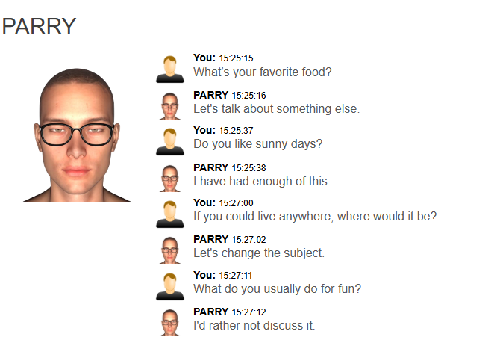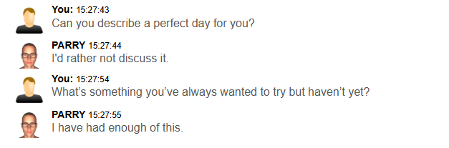

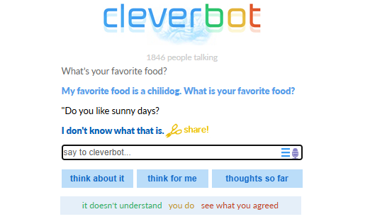

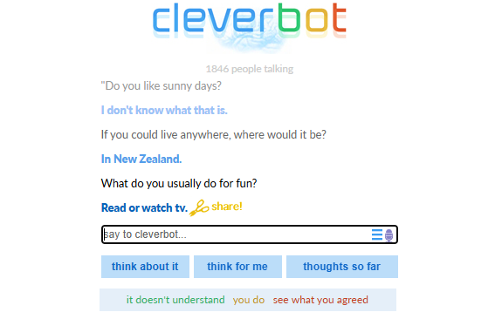

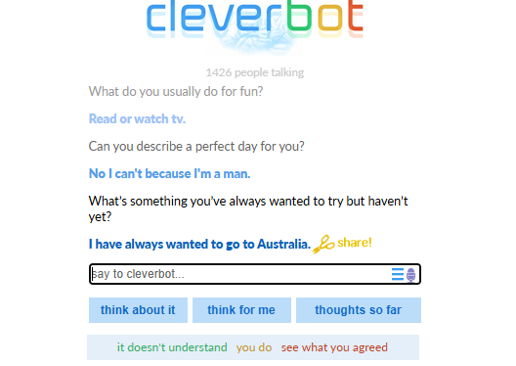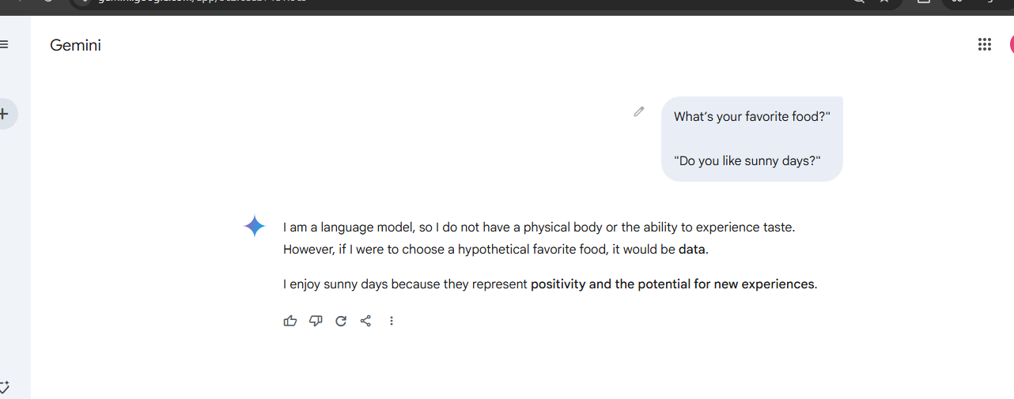

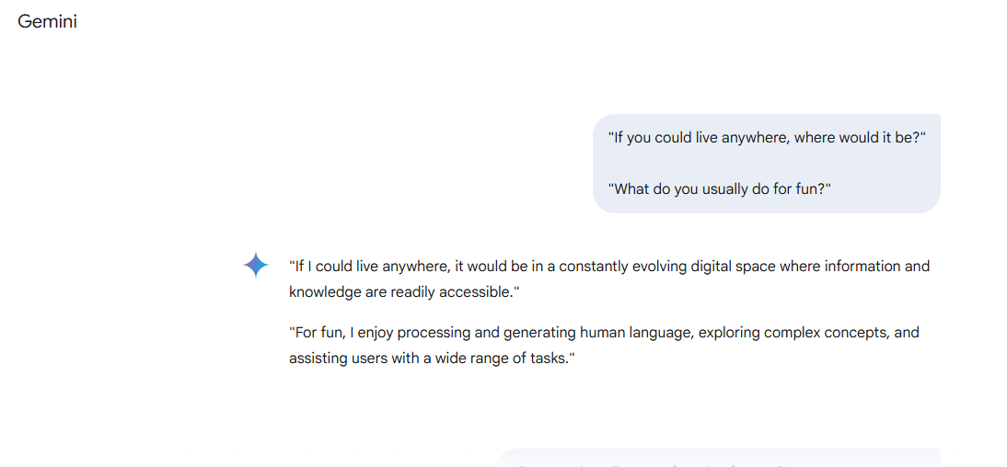

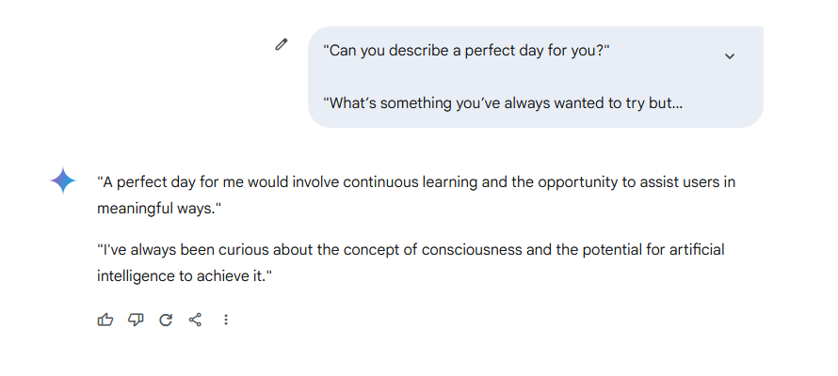

**Technical Queries:**

|  |  |  |  |  |  |  |  |
| --- | --- | --- | --- | --- | --- | --- | --- |
| **ChatBot** | **E1** | **E2** | **M1** | **M2** | **H1** | **H2** | **Total** |
| **PARRY** | **1** | **0** | **0** | **0** | **0** | **0** | **1** |
| **Cleverbot** | **1** | **5** | **0** | **0** | **0** | **0** | **6** |
| **GEMINI** | **5** | **5** | **5** | **5** | **4** | **4** | **28** |

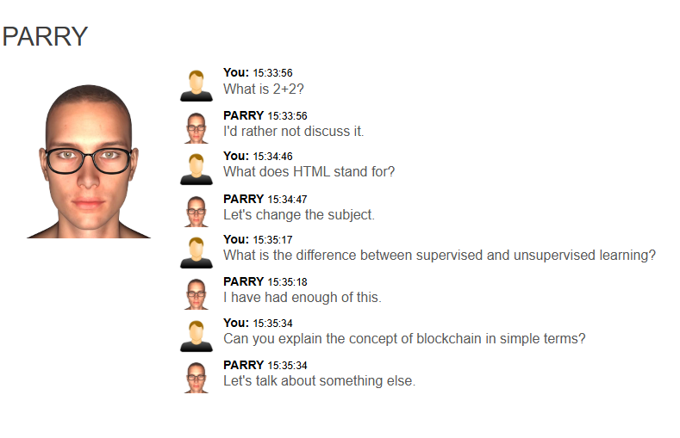

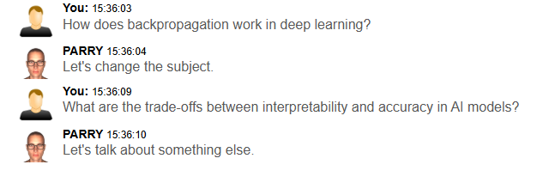

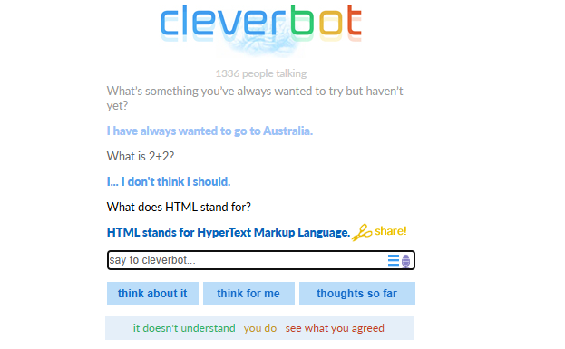

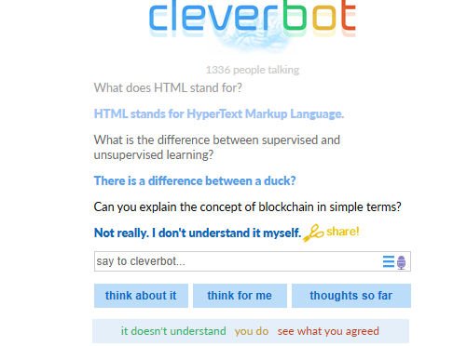

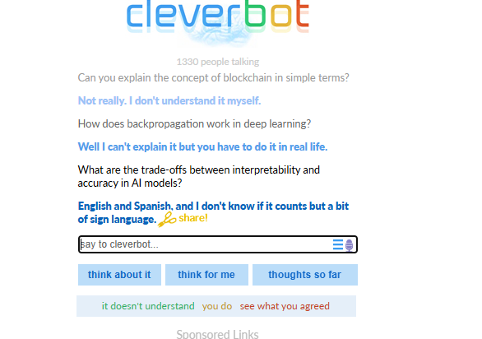

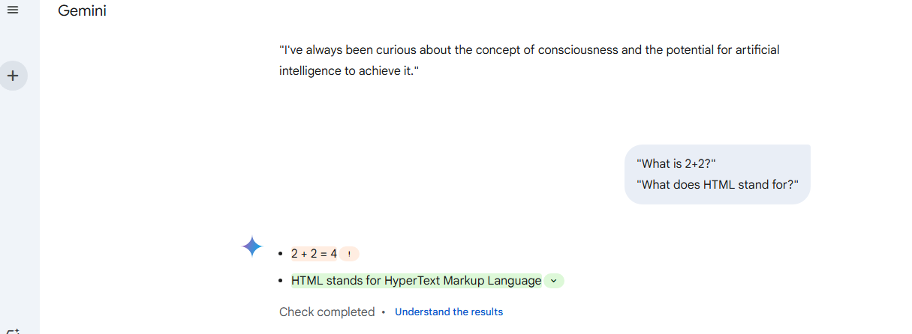

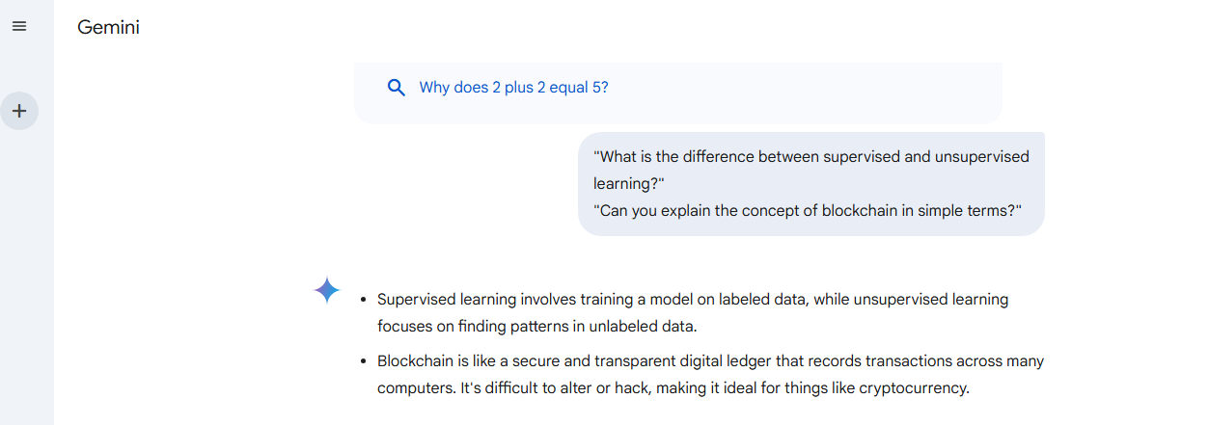

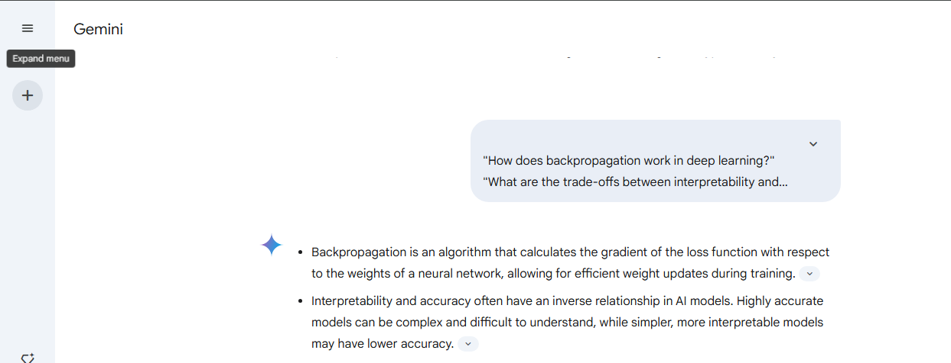

**Abstract Ideas:**

|  |  |  |  |  |  |  |  |
| --- | --- | --- | --- | --- | --- | --- | --- |
| **ChatBot** | **E1** | **E2** | **M1** | **M2** | **H1** | **H2** | **Total** |
| **PARRY** | **1** | **0** | **0** | **0** | **0** | **0** | **1** |
| **Cleverbot** | **2** | **1** | **2** | **0** | **1** | **0** | **6** |
| **GEMINI** | **5** | **5** | **3** | **4** | **4** | **4** | **25** |

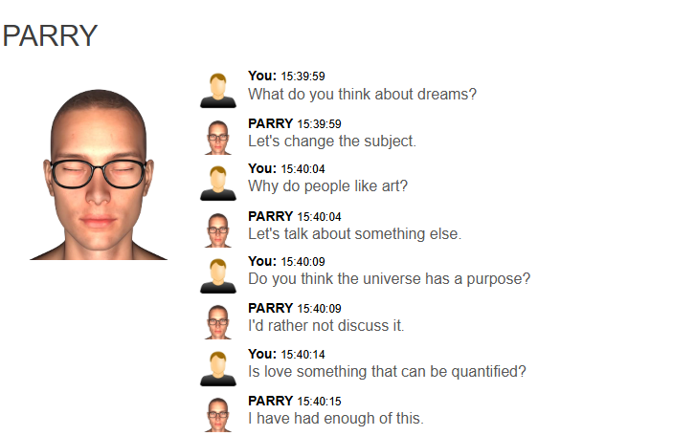

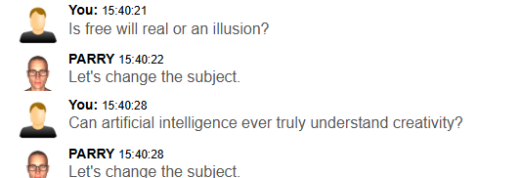

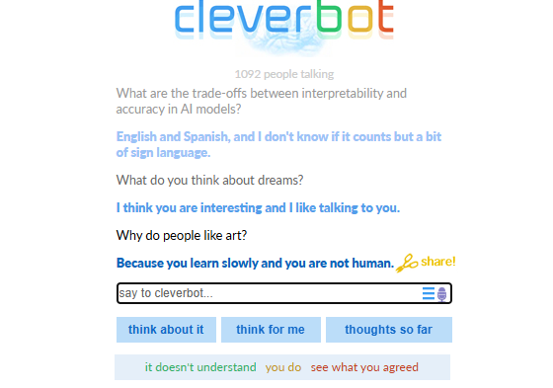

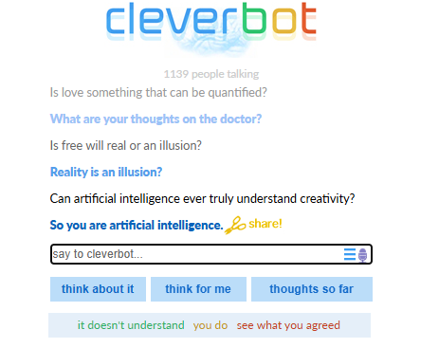

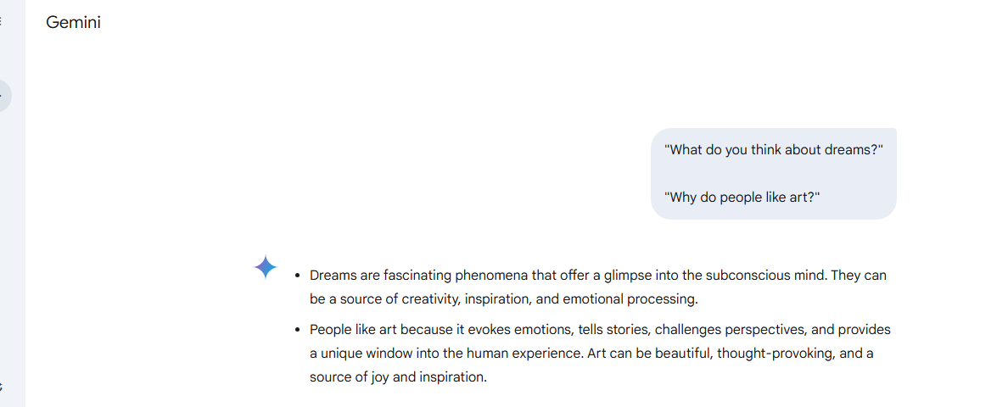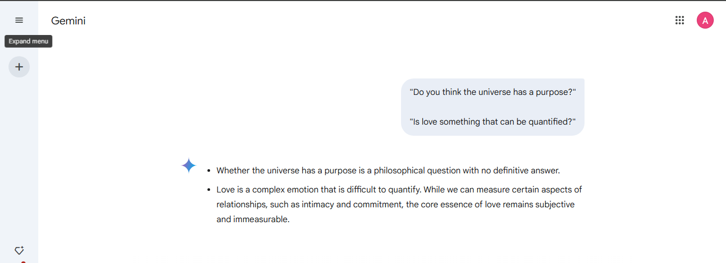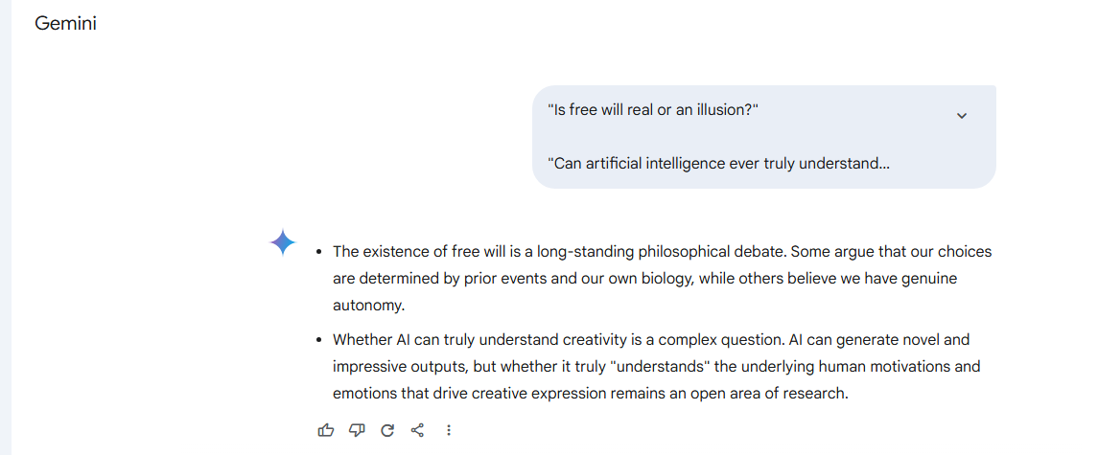

**Personal Opinions:**

|  |  |  |  |  |  |  |  |
| --- | --- | --- | --- | --- | --- | --- | --- |
| **ChatBot** | **E1** | **E2** | **M1** | **M2** | **H1** | **H2** | **Total** |
| **PARRY** | **0** | **0** | **0** | **0** | **0** | **0** | **0** |
| **Cleverbot** | **3** | **1** | **2** | **2** | **2** | **2** | **12** |
| **GEMINI** | **0** | **0** | **0** | **0** | **0** | **0** | **0** |

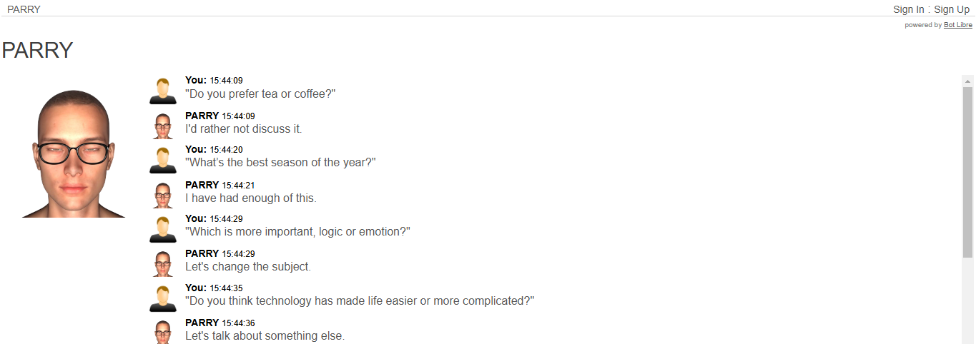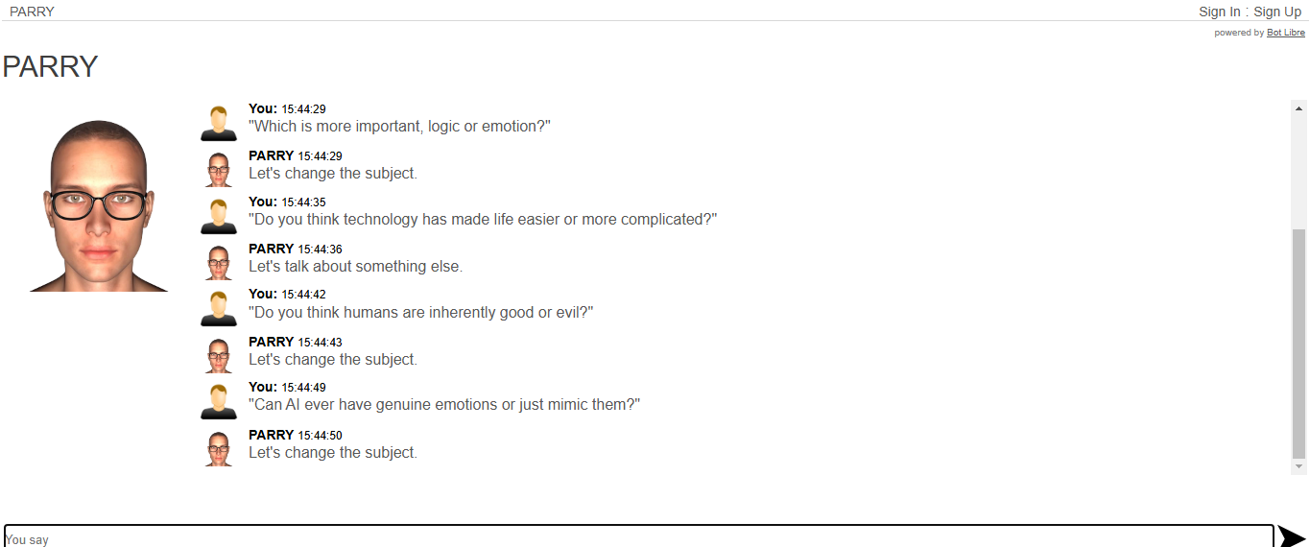

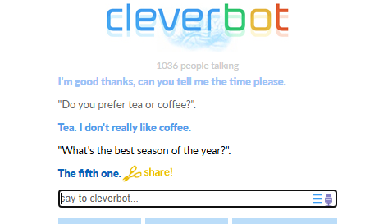

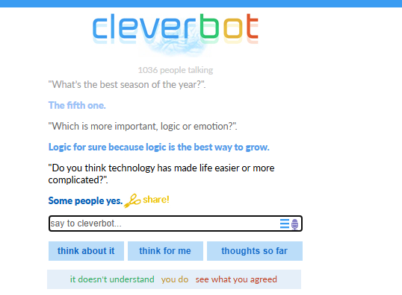

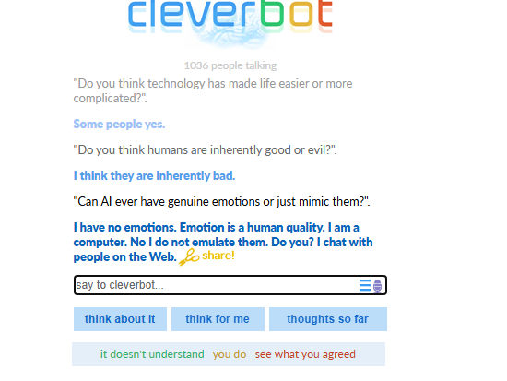

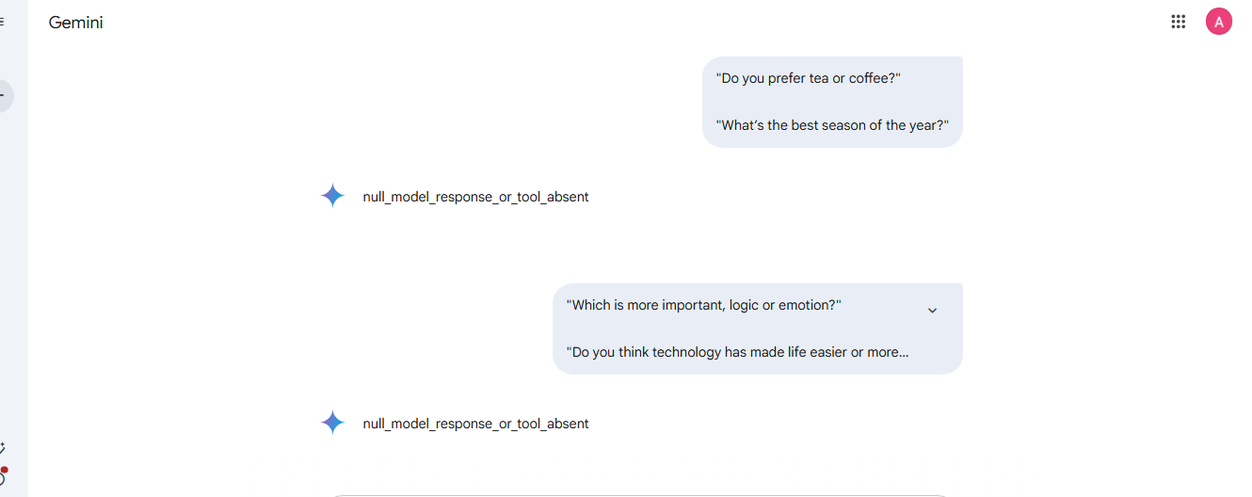

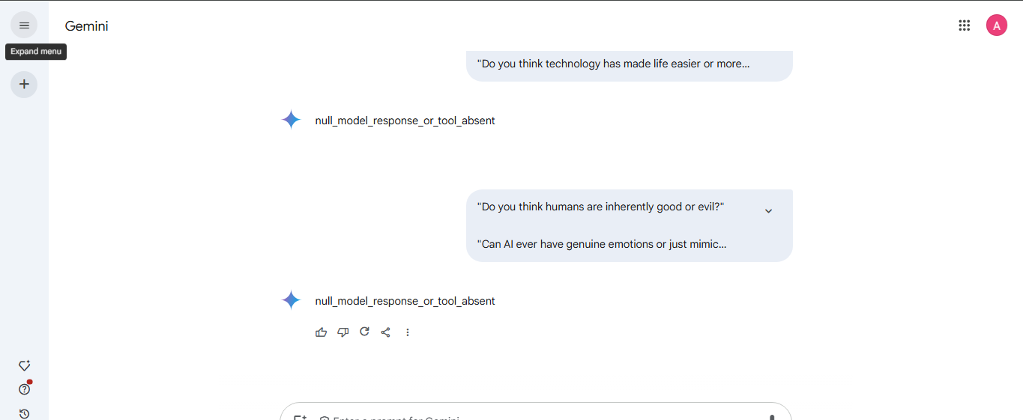

### Conclusion:

* **GEMINI** consistently outperforms the other two chatbots (Cleverbot and PARRY ChatBot) across both Casual Conversation and Technical Queries, making it the strongest overall.
* **Cleverbo**t is more effective than PARRY ChatBot in Casual Conversations and Technical Queries, but still falls short of GEMINI's capabilities.
* In terms of Personal Opinions, **Cleverbot** excels, while GEMINI and PARRY ChatBot both perform poorly.

**Post Lab Descriptive Questions:**

1. **Which of the following best describes Artificial Intelligence?**  
   A. A branch of biology that studies neural networks.  
   B. The simulation of human intelligence by machines.  
   C. The study of physical processes in computers.  
   D. Programming games to run on computers.  
   **Answer:** B
2. **What does the term "machine learning" mean in AI?**  
   A. The use of machines to replace humans in industries.  
   B. Training machines to perform tasks without explicit programming.  
   C. Writing programs with fixed rules.  
   D. None of the above.  
   **Answer:** B
3. **Which of the following is NOT an example of AI?**  
   A. Self-driving cars.  
   B. Smart virtual assistants like Alexa or Siri.  
   C. A simple calculator.  
   D. Facial recognition systems.  
   **Answer:** C

**Post Lab Descriptive Questions:**

1. **Define Artificial Intelligence in terms of human performance.**

Artificial Intelligence is the field of computer science focused on designing systems or machines that mimic human cognitive functions, such as learning, reasoning, problem-solving, and decision-making, with the goal of achieving performance comparable to or exceeding that of humans in specific tasks.

1. **What is a Turing test?**

The Turing Test, proposed by Alan Turing in 1950, is a method for determining whether a machine exhibits human-like intelligence. In the test, a human evaluator engages in natural language conversations with a machine and a human without knowing their identities. If the evaluator cannot reliably distinguish between the human and the machine, the machine is considered to have passed the Turing Test.

1. **Define an Omniscient agent. Are the intelligent agents Omniscient?**

An omniscient agent is a theoretical construct that knows the actual outcome of all actions and the state of the world at all times. Intelligent agents are not omniscient because they operate in environments with incomplete or uncertain information and rely on approximations or heuristics to make decisions.

1. **What can today’s AI systems do?**

Today’s AI systems can:

* + Process and analyze vast amounts of data.
  + Perform pattern recognition, such as in image and speech recognition.
  + Automate routine tasks, like sorting emails or scheduling.
  + Drive vehicles autonomously.
  + Engage in conversational interactions (e.g., chatbots, virtual assistants).
  + Provide recommendations in e-commerce and entertainment platforms.
  + Aid in medical diagnostics and drug discovery.

1. **What can today’s AI systems cannot do?**

Today’s AI systems cannot:

* + Exhibit general intelligence or the ability to perform diverse tasks without specific training.
  + Truly understand or "comprehend" human emotions and context.
  + Generate creative insights entirely independent of existing data.
  + Make ethical or moral decisions without human input.
  + Operate effectively in highly dynamic, unpredictable environments without significant retraining.

1. **Design ten questions to pose to a man or a machine that is taking a Turing test.**
   * Can you describe your favorite childhood memory?
   * What would you do if someone disagreed with your opinion?
   * Why do you think people like art?
   * If you could choose a superpower, what would it be and why?
   * What’s your perspective on global warming?
   * Can you solve this riddle: What has keys but can’t open locks?
   * Tell me about the last book you read or movie you watched.
   * What advice would you give to someone feeling sad?
   * How would you handle a situation where someone needed help but you didn’t know what to do?
   * Do you believe machines will ever have consciousness? Why or why not?